Executive Summary: Strategic Profit Optimization
Prepared For: Government Stakeholders
Operational Framework: Live Intelligence via Streamlit Cloud Deployment
Purpose of this Brief
This summary highlights the operational realities discovered through analysis of transaction patterns in Nassau Candy Distributor.csv. The goal is to provide corporate leadership and regional regulatory stakeholders with actionable insights to protect domestic supply networks, address structural product deficiencies, and stabilize operational margins.
Bottom Line Up Front (BLUF)
Nassau Candy's top-line revenue ($141,783.63) obscures major performance variances across its portfolio. A staggering 95.06% of all corporate profit is concentrated within just 5 chocolate products. Meanwhile, peripheral segments—specifically Kazookles—suffer from structural cost overruns that drain corporate cash flow, operating at an unacceptable 7.69% gross margin.
Key Financial & Operational Discoveries
- The Segment Deficit: The Chocolate division is highly optimized, capturing a 67.45% gross margin across 37,275 units. Conversely, the Other division lags severely at a 44.84% margin, driven down by inefficient pricing structures and heavy production costs.
- The "Kazookles" Vulnerability: Kazookles represents an active operational risk. It demands significant shipping volume across distribution routes but retains virtually zero cash value because product costs consume 92.31% of gross revenue.
- Extreme Portfolio Concentration: Nassau Candy exhibits a high-risk dependency profile. A supply chain or logistics disruption at Lot's O' Nuts or Wicked Choccy's manufacturing plants would halt nearly 95% of corporate profitability.
Corporate Profit Structure Profile:
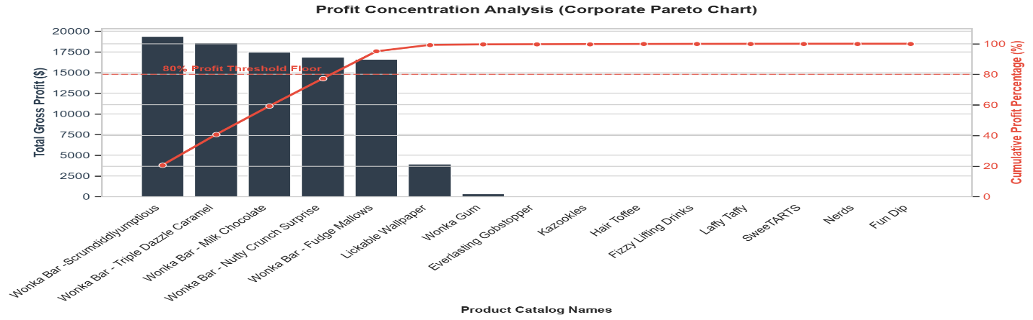
Live Governance and Controls via Streamlit Dashboard
To eliminate blind spots and transition from reactive management to data-driven oversight, we have built and deployed an interactive interactive analytics app.
- Product Leaderboards & Analytics: Instantly displays real-time performance metrics to separate high-volume items from actual profit drivers.
- Margin Threshold Flags: Features a dynamic slider allowing managers to isolate and flag items operating under target margin guidelines (e.g., highlighting items below a 50% margin threshold).
- Geographic Optimization: Incorporates latitude and longitude variables for all five factories (Lot's O' Nuts, Wicked Choccy's, Sugar Shack, Secret Factory, The Other Factory) to cross-reference product margin metrics with physical distribution coordinates, allowing logistics teams to optimize transport routes.
Immediate Action Plan
- Product Rationalization: Execute an immediate 25% wholesale price increase on Kazookles to absorb manufacturing overhead at The Other Factory. If market demand drops off, discontinue the product line to free up warehouse capacity for higher-yielding chocolate SKUs.
- Logistics Risk Mitigation: Coordinate with transportation partners to establish priority corridors for shipments originating out of the Arizona (Lot's O' Nuts) and Georgia (Wicked Choccy's) facilities, ensuring the core profit engine remains fully protected against supply chain friction.
- Continuous Data Audits: Embed the Nassau Candy Distributor.csv automated cleaning pipeline into quarterly financial reviews, institutionalizing objective, data-driven guardrails over historical, intuition-based decision patterns.

